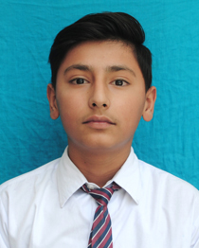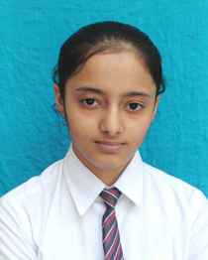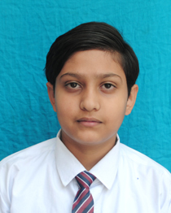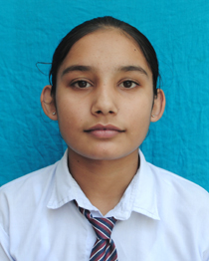

1ST AVNEET 94% 2ND RISHABH 90.4% 3RD SNEHDEEP 85.6% 4TH JASHANDEEP 85.4%
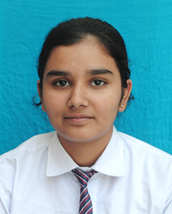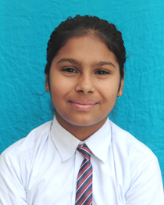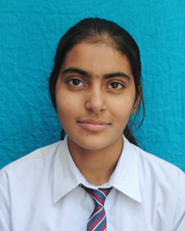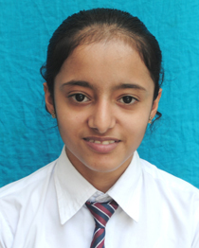

5TH SUPANDEEP 85% 6TH ARJU 84.6% 7TH SUMANDEEP 83.8% 8TH AKSHITA 83.6%
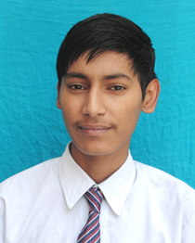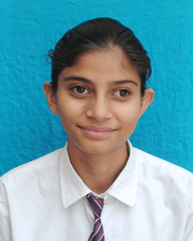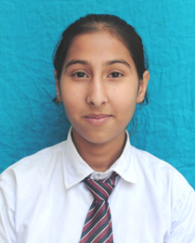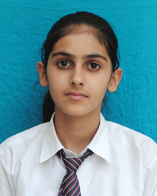

9TH ISHMITA 83.6% 10TH MANNAT 81.8% 11TH AISHMEEN 80.8% 12TH AKASH 79.2%
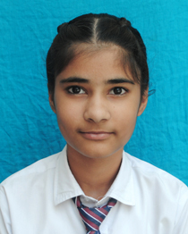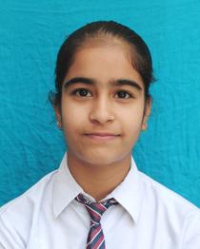

13TH BHUMIKA 78.4% 14TH VARINDER 75%
SUTLEJ PUBLIC SCHOOL, MANDI DABWALI.
Total students appeared: 33 Students in merit: 11 Students above 70% : 16
Students in 1st division: 24. Overall result 100%

